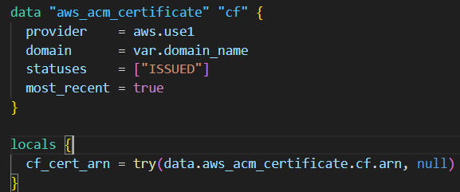
Purpose: Find an existing ISSUED ACM certificate for var.domain_name.
Why provider = aws.use1 matters: CloudFront requires the ACM certificate to be in us-east-1. So you’re intentionally looking it up in us-east-1.
most_recent = true: If multiple certs match the domain, pick the newest.
try(..., null): If the lookup fails (no cert found, wrong domain, wrong region), local.cf_cert_arn becomes null instead of throwing an immediate hard crash in the locals evaluation. (CloudFront will still fail later if it needs a cert and gets null.)
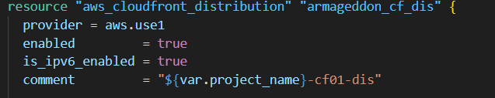
Creates a CloudFront distribution (your edge/CDN entry point).
Enabled + IPv6 enabled.
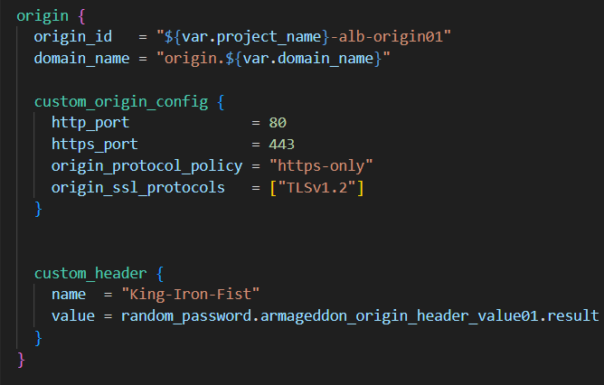
Origin domain: origin.${var.domain_name} (commonly a Route53 record pointing to an ALB).
custom_origin_config: used for “non-S3 origin” (ALB/EC2/etc).
- https-only: CloudFront → origin always uses HTTPS.
- Only allow TLS 1.2 to origin.
custom_header: CloudFront adds a secret header (King-Iron-Fist: <random>) on every request to the origin.
- This is origin cloaking: your ALB/NGINX can be configured to only accept traffic if that header matches, blocking direct-to-origin bypass attempts.

CloudFront has:
- default_cache_behavior: catch-all rule.
- ordered_cache_behavior: more specific rules by path_pattern. They are evaluated in order of specificity/priority.
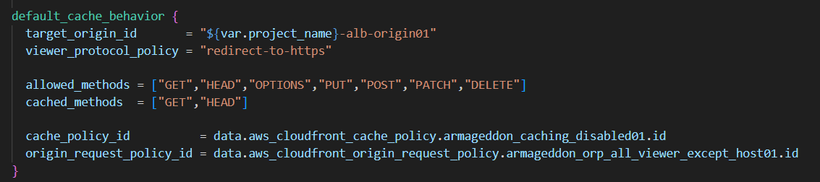
Viewer protocol: HTTP users get redirected to HTTPS at the edge.
Allowed methods: CloudFront will accept all common HTTP methods (good for APIs).
Cached methods: only caches GET/HEAD (normal).
Cache policy: Managed-CachingDisabled means effectively no CDN caching (TTL 0). This is typical for dynamic API traffic.
Origin request policy: Managed-AllViewerExceptHostHeader
- Forwards most viewer headers/cookies/query strings but does NOT forward the Host header.
- This often avoids host-header confusion at the origin, but it also means your origin won’t see the original Host the client used.
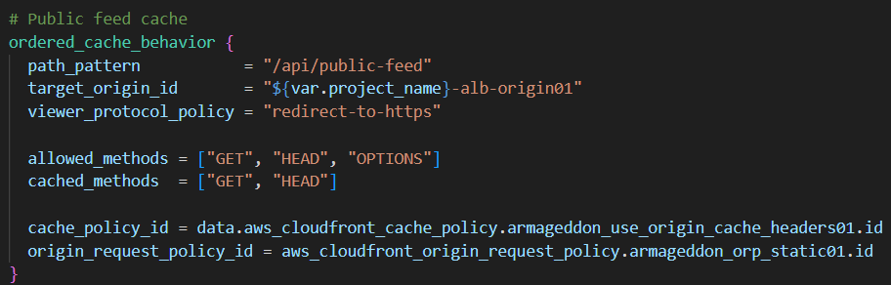
This path is treated like a “public endpoint” that can be cached.
Cache policy: UseOriginCacheControlHeaders means CloudFront will follow Cache-Control headers from your origin (e.g., max-age=60, s-maxage, etc.).
Origin request policy: you’re using a custom origin request policy (armageddon_orp_static01)—typically this forwards fewer headers/cookies/query strings (better cache hit rate). (Its exact behavior depends on how you defined it elsewhere.)
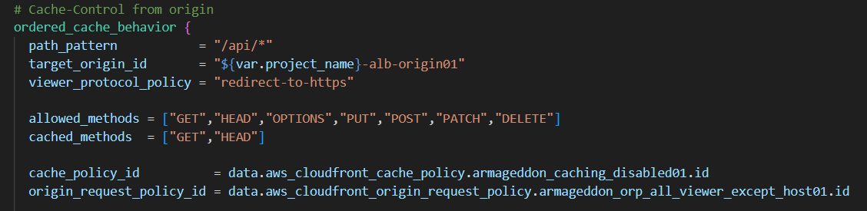
All other API calls are not cached at CloudFront.
Same forwarding behavior as default.
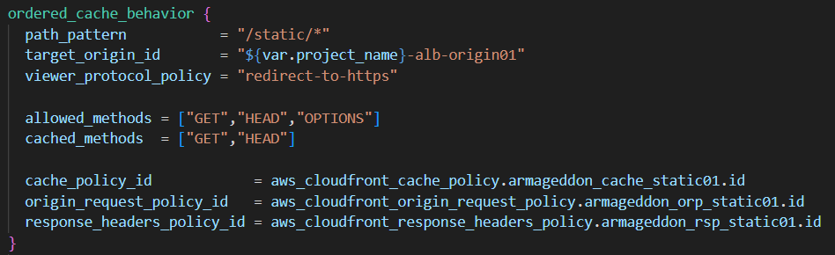
Static files get a custom cache policy (usually long TTL + optimized cache key).
Response headers policy likely adds security headers and/or caching headers (depends on your definition).
Attaches your WAFv2 Web ACL to the distribution, so inspection happens at the edge
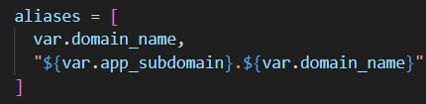
The distribution will respond to both:
- example.com (root/apex)
- app.example.com (subdomain)
Requires DNS records pointing those names to the distribution and a cert covering those names

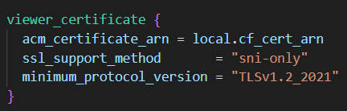
Uses the ACM cert you looked up earlier (must be us-east-1)
sni-only: normal modern TLS hosting (no dedicated IP needed)
TLS minimum is fairly modern (TLSv1.2_2021)
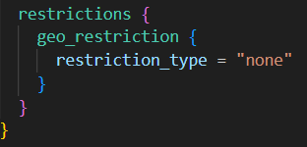
No country blocking
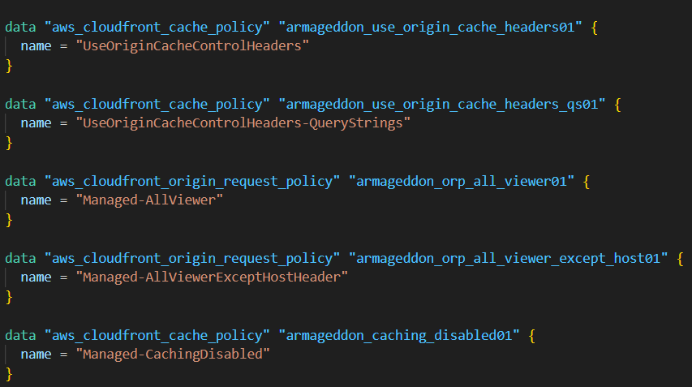
It’s fetching their IDs by name so you can reference them in behaviors without recreating them.

